UI Screenshots

Enter a description, Add Attendees…

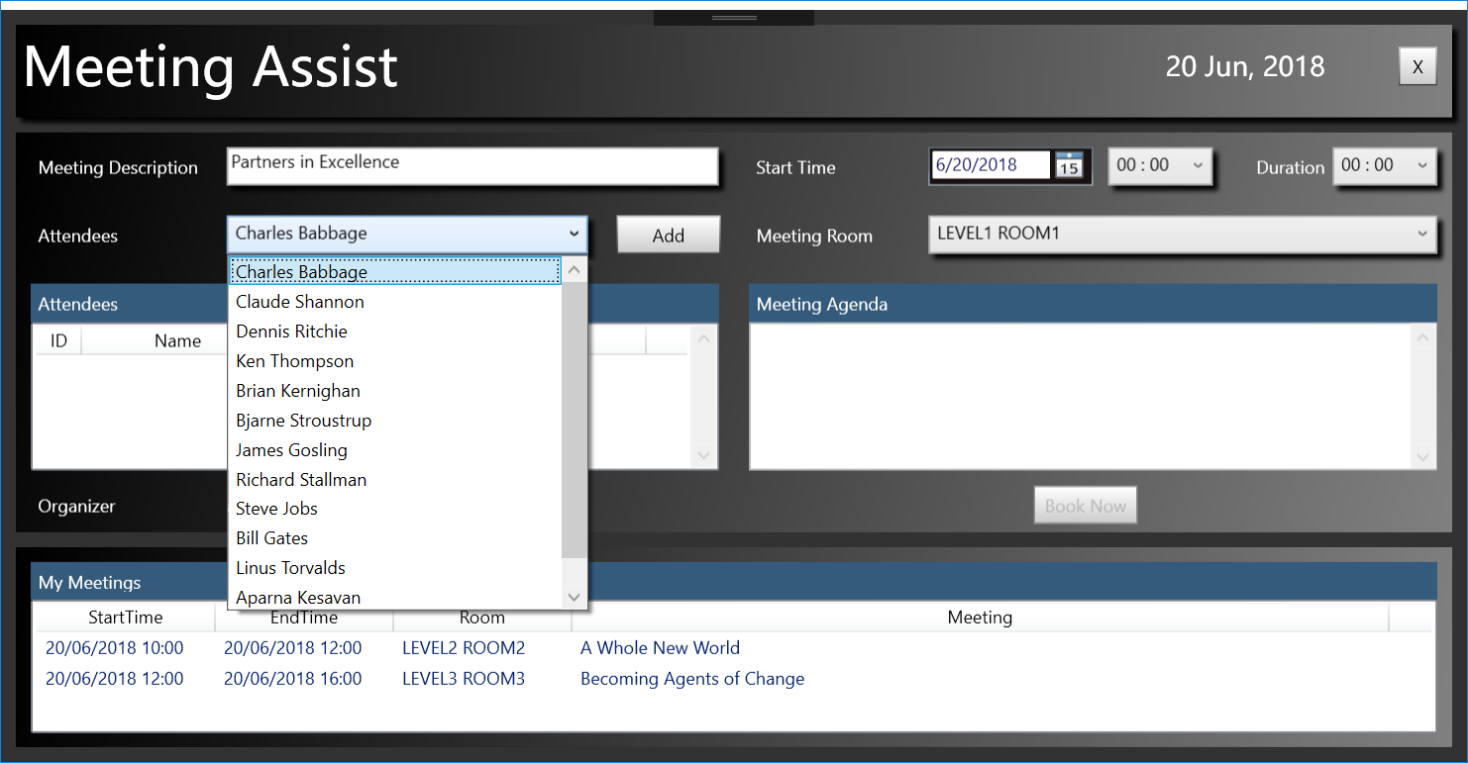

Select Date, Start time and duration…

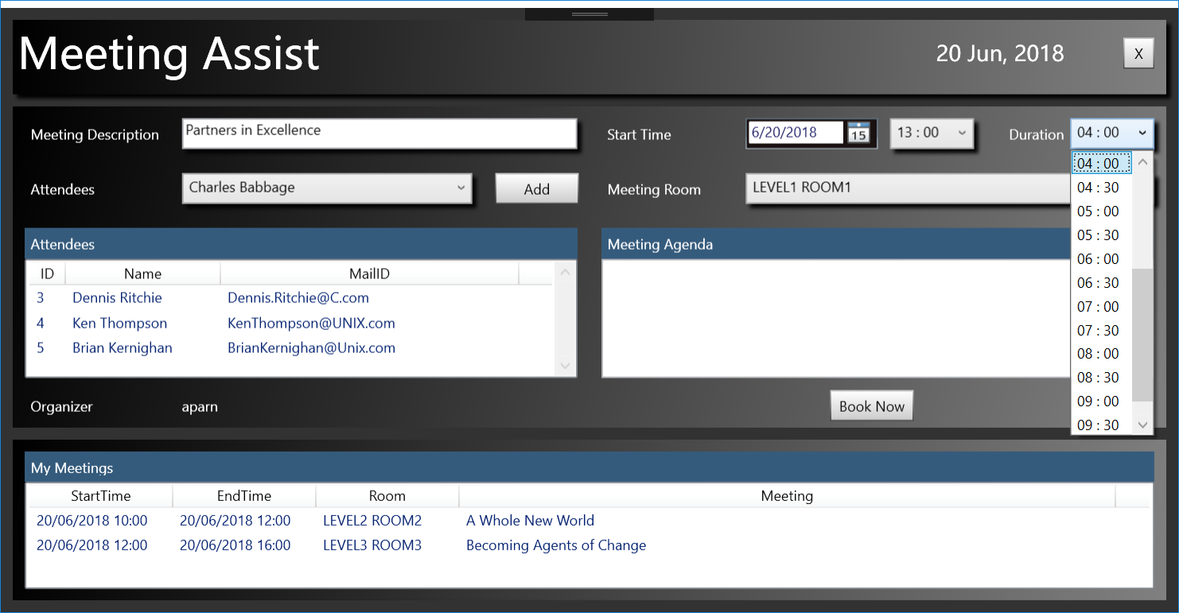

Select Meeting Room and Meeting Agenda

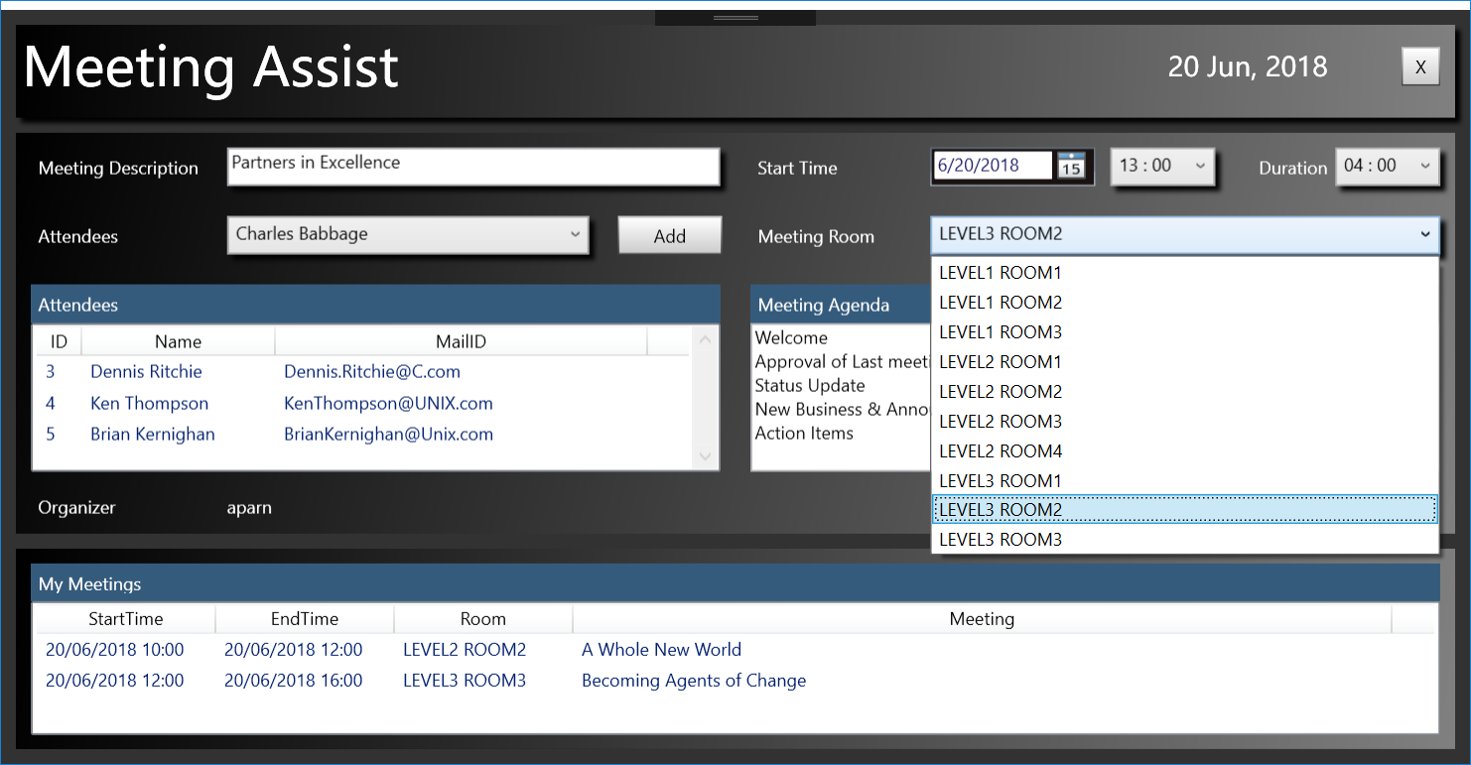

Click on “Book Now” to book the Meeting.

